**SOUVENIR PROGRAM MESSAGES**

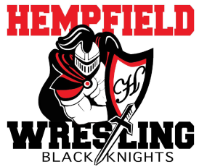

Dear Hempfield Wrestler and Cheerleader Parents:

The Black Knight Wrestling Club is putting together a Souvenir Program for the 2019-2020 wrestling season. We would like to invite you to include a few words of encouragement or congratulations to your wrestler or cheerleader. There is no cost for a message. If you wish to include a photo, the cost is $5.00. You must label the photo with the name, phone number and team info so we can make sure it is returned to you.

The message and/or photo may be delivered by:

1. Sending via email to: abrandt09@live.com
2. Mailing to: Alyssa Brandt, 106 Running Pump Rd. Lancaster, Pa 17603

All messages and photos **must be received by November 27, 2019** in order to meet the printing deadline. We will not be accepting late submissions this year. Please make checks payable to **Black Knight Wrestling Club**.

**Please print legibly!**

Contact Name____________________________________________ Phone ____________________

Email ___________________________________________________

Cheerleader/Wrestler Name ________________________________________________ Grade______

Message______________________________________________________________________________

_____________________________________________________________________________________

_____________________________________________________________________________________

_____________________________________________________________________________________

_____________________________________________________________________________________

Signed _______________________________________________________________________________

_____________________________________________________________________________________

We hope to have programs printed by the first home match. If you have any questions, please contact Alyssa Brandt by emailing abrandt09@live.com or call/text (717)808-2139.