BLACK KNIGHT WRESTLING CLUB
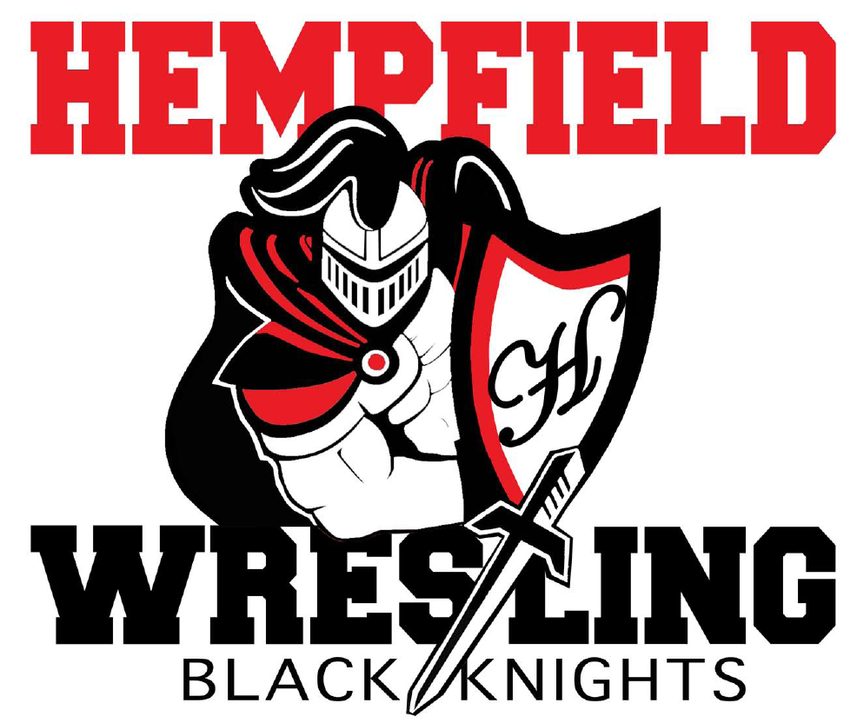
BOARD MEETING
MINUTES

May 16, 2022

- Welcome- Dylan Bard called meeting to order at 7:08 pm
  - Introductions-members in attendance introduced themselves in round table order: Dylan Bard, Shane Mack, Chris Williams, Josh Mussmon, Amy Edwards, Matt Deck, Jim Schopf, Nate Cote, Al Houck, Jim Lefevre, Ian Edwards, Bob Biddle, Mike Rush, Paul Karpathios, Josh Parmer, Ed Pfursich, Jesse Trowbridge, Justin Myers.
  - April Minutes- motion to approve by Bob Biddle, Jim Lefevre second. Motion passed.

- Election- Dylan Bard prepared ballots which were distributed, cast, and collected.

- Budget- $ 9,694.79 checking balance
  - Checks not Cleared $802.62/150.00/233.59/490.34 @ Credit card)
  - Credit Card $ 79.97 DUE 5/23/22
  - High School Banquet $1676.55
  - Jr High Banquet $189 food, $132 gifts, $100 donation to church
  - Budget Meeting June 7, 7:00pm at the Barn, establish 2022/23 budget.

V. Committees
a. MAY 22nd CHICKEN BARBECUE $5241.00 COLLECTED SO FAR.
b. 10 am start, 3 adults needed in trailer at beginning to pack. Dylan will provide change. Jim Schopf updated list: ordered 1100, 900 spoken for. Walkins will be provided from 12-2.

VII. New/Unfinished Business
- High School Banquet was a success. Senior speeches were outstanding.
- Josh Mussmon read a thank you note from junior Sam Fields for the gift basket sent on behalf of the team.
- Center mat in Barn is damaged. It is being assessed for warranty. School District also contributing.

Nate Cote motioned to adjourn meeting at 7:53, Paul Karpathios second.

Next meeting dates at hempfieldwrestling.com

