BLACK KNIGHT WRESTLING CLUB
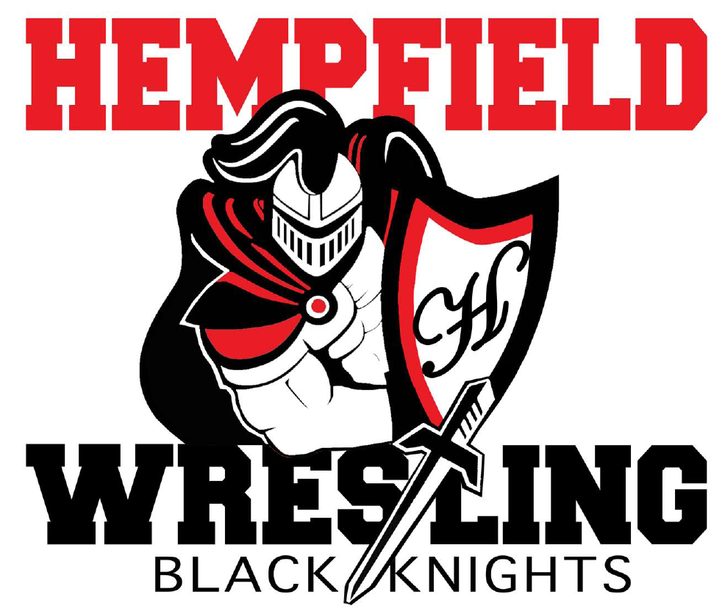
BOARD MEETING
MINUTES

August 10, 2022

- Welcome- Jim Schopf called meeting to order at 7:02 pm
  - Introductions-members in attendance introduced themselves in round table order: Shane Mack, Lawrence Beckman, Chris Williams, Amy Edwards, Dana Edwards, Jim Schopf, Al Houck, Josh Parmer, Ed Pfursich, Justin Myers.
  - May Minutes- motion to approve by Lawrence Beckman, Amy Edwards second. Motion passed.
  - President Jim Schopf- Explained how he would like the meetings to be conducted structurally with regard to reading/approving the minutes, updates, Treasury reports, fund raising, upcoming items and new and unfinished business.

- Updates
  - Youth Registration- Will open October 1st and run through October 31st (soft close). Costs will be $100.00 for all wrestlers participating on the boys and girls youth teams. Scholarships for those who may have need are available. Team Snap will be used for registration.
  - Penn State Health- may supply equipment for youth for upcoming season, a discussion was held around how to “raise our game” and get more participation for help in this area. Nate Cote is soliciting these funds.
  - Season Recruitment- Discussed who is recruiting in what fall sports to increase participation. Hempfield football and fall baseball teams have representatives encouraging recruitment. Also discussed where and how to book the preseason parent meeting on 10/17/22. It was agreed the Hempfield High School building would be the best area for this.
  - High School-Practice start date has been set for 11/18/22. Discussion was had on who pays for what, home/away matches, and budget.
  - Junior High- Practice start date has been set for 11/18/22.
  - Youth Coaching- Updates were discussed on which coaches will be doing which rooms and what levels.

- Treasurer’s Report –We currently have a balance of $7,135.26. This does not include any expenses or income from the upcoming golf outing.
  - Budget- Still waiting on finalized budget. Coach Biddle is organizing the notes on this in order for everyone to review.
  - Chicken BBQ-Went well and had better participation.

- Fundraising

  - Schedule- Discussion was had on what dates for the golf outing may be better for participation and productivity. It was decided the golf outing fundraiser for 2023 should be booked for September 23, 2023.
  - Golf Fundraiser- There is a need for more teams of four to play in the fundraiser. In the last 48 hours the money and sponsors have picked up. Thoughts on how to get more participation and communicate the fundraiser to the public.

- Upcoming Items
  - Women’s National Team Event at The Barn-$3000.00 was donated to the program in exchange for help cleaning the facility each day of the event. Jim Schopf gave an explanation of the accommodations and schedule for the week. Coach Schopf will coordinate cleaning teams for the week.
  - Raffle Ticket Fundraiser-A discussion was held around the possibility and requirements of a raffle ticket fundraiser. Discussed possibly doing it at the beginning of the season and having the drawing at the end.
  - Super Bowl Scramble Fundraiser- Paul Karpathios will be running this fundraiser.

VI. New/Unfinished Business
- Discussion held on holding a youth CPWA event and restaurant fundraisers for fundraising.
- Start thinking about equipment now, gear takes longer to get lately.
- Banner order updates were given and a discussion of where to hang them when they come in was had.

Coach Mack motioned to adjourn meeting at 8:00 pm, Dana Edwards second. Motion passed.

All meeting dates at hempfieldwrestling.com
Next Meeting Date September 14, 2022 at 7:00pm

