BLACK KNIGHT WRESTLING CLUB
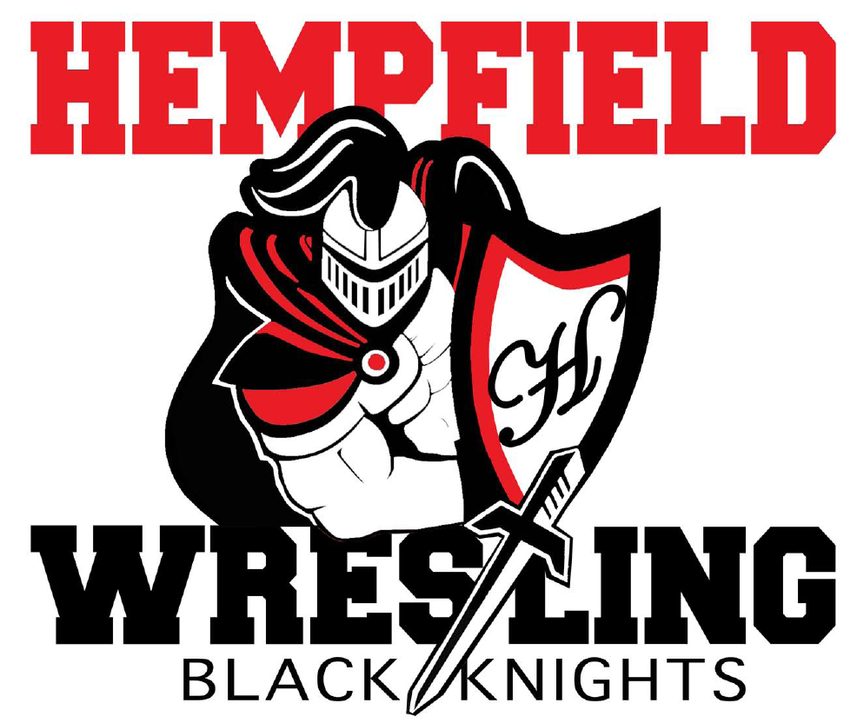
BOARD MEETING
MINUTES

September 21, 2022

I. Welcome- approval of minutes from August 10, 2022
-Members present: Jim Schopf (President), Ed Pfursich (Vice President), Dylan Bard (Treasurer), Josh Parmer (Secretary), Mike Rush, Lawrence Beckman, Dana Edwards, Ian Edwards, Bob Biddle, Al Houlk
-A motion to approve the minutes from 8.10.22 was made by Lawrence Beckman and seconded by Bob Biddle. The minutes were then approved as read.
-The meeting proceeded according to the agenda set by the President.
II. Coach & Liaison Reports
- Girls – fall practices, registration date Oct 1-31, $100 per wrestler, Team Snap, Parent Night, Picture Night, fundraising requirement, start date Nov 14, practice locations, recruitment
-Discussed and mention was made that the LL League has met to determine details, budgets and other numbers.
- Youth – fall practices, registration date Oct 1-31, $100 per wrestler, Team Snap, Parent Night, Picture Night, fundraising requirement, start date Nov 14, practice locations, recruitment (yard signs, flyers to schools, football), schedule, tourneys
-Discussed according to agenda and mentioned was made by Coach Rush that club waivers can be taken care of through the Team Snap app. Also mentioned open mats has continued through the fall and a takedown tournament is in the works for December 4th.
- Junior High – fall practices, start date Nov 18, coaching roster, recruitment – meetings at LMS and CMS, schedule
-Discussed according to agenda, October presentations will be given at LMS and CMS to recruit wrestlers for the upcoming season.
- Senior High – fall practices, lifts, start date Nov 18, coaching roster, concussion and hydration dates, recruitment, schedule - overnights
-Discussed according to agenda and Coach Mack informed the board that Lawrence Beckman will be coaching high school this year. Fall practices still occurring on Mondays and Thursdays. Lifting is taking place Sunday, Monday and Thursdays. The school will be covering this year’s VA Duals event up to $10,000.00. Discussion was also had on what to buy Jr. High and High School teams (sweat pants or shorts?).

III. Treasurer’s Report
- Golf Outing profit – Went well, next year the outing will occur between the 16th and 23rd of September. Coach Beckman discussed a potential text message fund raiser for future consider.
- Account Balance -
- Outstanding Debits -
- Outstanding Credits -
- Budget Approval

IV. FUNDRAISING
A. FUNDRAISING
1. Golf Outing Report from Lawrence Beckman.
a. Best date for 2023? – Sept 23rd?
-Discussed as mentioned in the agenda.

2. Barn Cleaning for Women’s World Team – thank you to those who helped in exchange for $3,000 donation from Steve Capoferri.
-Discussed as mentioned in the agenda, thanks to all who helped out

3. SpiritWear – Squadlocker vs Traditional vs Rudis
a. Squadlocker – 87 items in store, 31 orders, 75 items sold, $2,681.40 in sales, our cut is 15%. This is from 12/15/21 until present. Most orders occurred from 12/15/21 – 12/30/22.
b. Traditional is more work but more profit
c. Rudis is nice gear but expensive and less profit and more work
-Discussed as described in the agenda

4. Field of Screams – Saturdays in October – parking, scaring, trash. Jim will send out details
-Discussed as presented on the agenda. Please encourage as many that can to help

5. Raffle Tickets – Print 5,000 tickets. Each family pays $100 for 25 - $4 raffle tickets. There would be roughly 4,000 tickets out there (120 youth, 30 JH, 20 HS). The idea is that they sell these tickets to friends, etc. Can sell individually or 5 tickets for $20 would be the best option. This generates approximately $16,000 in gross income. We can decide how much we want to give out in prizes. Maybe one grand prize of $2,000 with a second prize of $1,000 and two third prizes of $500 and 10 fourth prizes of $100 and 40 fifth prizes of $25. This would be $6,000 in prize money and $10,000 in profit. Do we need a small games of chance license? We need someone to head this up.
-Vice President Ed Pfursich volunteered to look into these details

6. Program Booklet. We need someone to head this up

7. Super Bowl Fundraiser – Karpathios?

8. Park City Diner Fundraiser Reminder

9. Past Discussions – Youth CPWA event at HHS, Pancake Breakfast, Restaurant partnerships, Lancaster Extra Give (Cote).
-All discussed as presented in the agenda. Pancake breakfast is going to be tabled until spring.

V. UPCOMING ITEMS
A. Gear Order for all teams
B. Senior Night – Need HS non-senior parent to lead this
C. HS Banquet – on here for future meetings
D. JH Banquet – on here for future meetings
E. Youth Banquet – on here for future meetings

-All discussed as listed in agenda. Presently there is a need for someone to help with the senior night.

VI. NEW/UNFINISHED BUSINESS
- Updated banner project – where do we stand – getting second quote.
- Ed and Josh – need headshot photo for website
-Discussed as presented on the agenda. Parmer and VP report having sent photos to be posted. Also mention was made about keeping clearances up to date and how to obtain them if new to the program.
-President asked if there was anything else for the good of the order. Hearing none, Dr. Edwards made a motion to adjourn, it was seconded by Coach Houck and the motion was unanimously carried.

Next Meeting Date October 5, 2022 at 7:00pm
All meeting dates at hempfieldwrestling.com – Oct 5, Nov 9, Dec 12, Jan 9, Feb 8, Mar 8, Apr 12, May 10

