BLACK KNIGHT WRESTLING CLUB
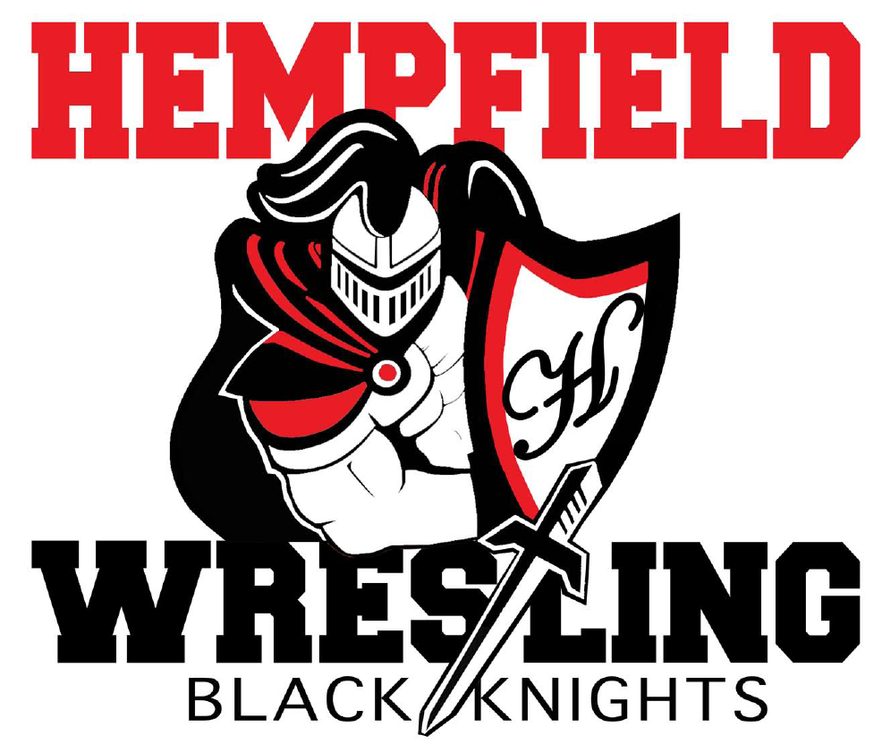
BOARD MEETING
Minutes

October 5, 2022

- Welcome- approval of minutes from September 21, 2022
Members Present: Jim Schopf (President), Ed Pfursich (Vice President), Dylan Bard (Treasurer), Josh Parmer (Secretary), Mike Rush, Lawrence Beckman, Nate Cody, Dana Edwards, , Bob Biddle, Al Houck, Paul Karpathios
-The meeting was called to order by President Jim Schopf at 7:09 pm.
-A motion to approve the minutes from 9.21.22 was made by Coach Lawrence Beckman and seconded by Coach Al Houck. The minutes were then approved as read/distributed.
-Dylan Bard reminded the committee that minutes should be posted online once they have been approved.
-The meeting proceeded according to the agenda set by the President.

II. Coach & Liaison Reports
- Girls – fall practices, registration open through Oct 31, $100 per wrestler, Team Snap, Parent Night, Picture Night, fundraising requirement, start date Nov 14, practice locations, recruitment
-Girls sign-ups are presently between 20-30 participants, all agenda items discussed and deliberated as set in the agenda
- Youth – fall practices, registration open through Oct 31, $100 per wrestler, Team Snap, Parent Night Oct 17, Picture Night, fundraising requirement, start date Nov 14, practice locations, recruitment (yard signs, flyers to schools, football), schedule, tourneys
-Discussed agenda items as presented in agenda
-33 participants signed up thus far, Team Snap sign-up app is working well
-Beckman is recruiting from fall sports teams
-Singlets, coaches shirts have been ordered and invoices sent
-Alex Oracia is our Rudis Rep at this time
-It was reported that the East Petersburg Church/Community Center is changing hands with another Church and the continued relationship for building use for youth practices is being pursued
- Junior High – fall practices (can join Youth), start date Nov 18, coaching roster (Cote, Ruhl, Deck, Houck), recruitment – meetings at LMS and CMS, schedule week of Oct 10-14 at 2:00 flex.
-Coach Cody reported that the schedule is set, questions and opinions given concerning sweat pants and/or shorts should be chosen for team. Team sign-ups set for Oct 17 at CMS and Oct 18 at LMS/HHS.
- Senior High – fall practices, lifts, start date Nov 18, coaching roster, concussion and hydration dates, recruitment, schedule - overnights

III. Treasurer’s Report
- Golf Outing profit - $8,800 plus some outstanding sponsors
- Account Balance – $18,906.09
- Outstanding Debits - see Treasurer’s submitted checking report for the last thirty days as presented.
- Outstanding Credits - see Treasurer’s submitted checking report for the last thirty days as presented.
- Budget Approval-Due to the issue of a quorum it was moved by Coach Biddle to conduct the vote by email from the President of the Club. Seconded by Josh Parmer. Motion was approved unanimously. Email will be forthcoming.

IV. FUNDRAISING
A. FUNDRAISING
1. Golf Outing Report from Lawrence Beckman.
a. Best date for 2023? – Sept 23rd?
-Dates discussed nothing set exactly
2. SpiritWear – Squadlocker Jim L is updating designs.
-Discussed
3. Field of Screams – Saturdays in October – parking, scaring, trash. See details
-Discussed and members were encouraged to help and get other helpers.
4. Beckman Idea – kids ask 10 people to donate
-Discussed this item again, Coach Beckman would like to put this fund raiser on hold and spread out the fundraisers more. A January date was suggested for this.
5. Raffle Tickets – Print 5,000 tickets. Each family pays $100 for 25 - $4 raffle tickets. There would be roughly 4,000 tickets out there (120 youth, 30 JH, 20 HS). The idea is that they sell these tickets to friends, etc. Can sell individually or 5 tickets for $20 would be the best option. This generates approximately $16,000 in gross income. We can decide how much we want to give out in prizes. Maybe one grand prize of $2,000 with a second prize of $1,000 and two third prizes of $500 and 10 fourth prizes of $100 and 40 fifth prizes of $25. This would be $6,000 in prize money and $10,000 in profit. Do we need a small games of chance license? We need someone to head this up.
– Ed Pfursich reviewing.
6. Program Booklet. Jim and Amy head up?
-discussed and it is reported to be underway
7. Super Bowl Fundraiser and March Madness – Karpathios?
-Discussed no set date
8. Park City Diner Fundraiser Reminder
-Discussed and everyone was reminded
9. CPWA Takedown Tournament Dec 4 at HHS
-discussed and it was emphasized that we will need much help from Club

10. Past Discussions – Pancake Breakfast, Restaurant partnerships
-Discussed on hold at this time for pancake breakfast

V. UPCOMING ITEMS
A. Gear Order for all teams
B. Senior Night – Need HS non-senior parent to lead this
C. HS Banquet – on here for future meetings
D. JH Banquet – on here for future meetings
E. Youth Banquet – on here for future meetings
-Discussed as was necessary, still in need of a HS parent to step and run this as former helpers have seniors who will be recognized at this year’s Senior Night.

VI. NEW/UNFINISHED BUSINESS
- Updated banner project – where do we stand – Fast Signs quote is $524.49 and Advanced Quote is $376.30

-President asked if there was anything else for the good of the order. Hearing none, Dr. Edwards made a motion to adjourn, it was seconded by Coach Cote and the motion was unanimously carried. The meeting closed at 8:01 pm.

Next Meeting Date November 9, 2022 at 7:00pm
All meeting dates at hempfieldwrestling.com – Dec 12, Jan 9, Feb 8, Mar 8, Apr 12, May 10

