BLACK KNIGHT WRESTLING CLUB
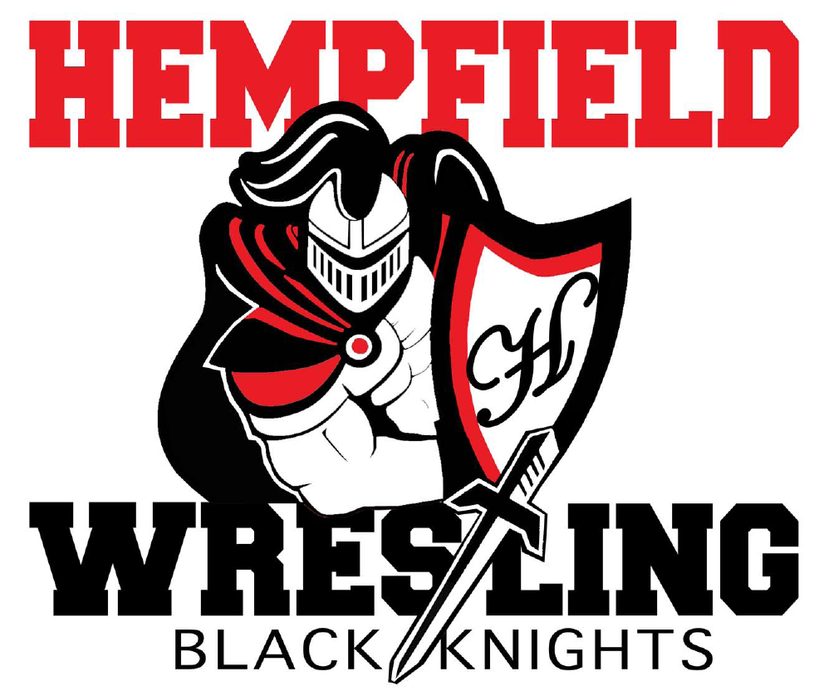
BOARD MEETING
Minute

January 9, 2023

- Welcome - approval of minutes from December 12, 2022
Members Present: Jim Schopf (President), Ed Pfursich (Vice President), Dylan Bard (Treasurer), Josh Parmer (Secretary), Shane Mack, Mike Rush, Nate Cote, Lawrence Beckman, Amy Edwards, Bob Biddle, Chris Williams, Justin Myers, Josh Mussman
-The meeting was called to order by President Jim Schopf at 7:08 PM.
-A motion to approve the minutes from 12.12.22 was made by Dylan Bard and seconded by Chris Williams. The minutes were then approved as read/distributed.
-The meeting proceeded according to the agenda set by the President.

II. Coach & Liaison Reports
- Girls – Have secured their first win via Vanessa Houck.
- Youth – Coach Biddle gave an update on the Garden Spot Tournament and the Elizabethtown Quads, the youth wrestlers are doing well. The roller skating party is scheduled for 2.28.23.
- Junior High – Coach Cote gave an update on a close match with Penn Manor and win over Warwick. He reports the team is solid from top to bottom. Their banquet will be 2.19.23 at Coach Houck’s Church.
- Senior High – Coach Mack gave an update on the progress of the high school team. Conestoga Valley will be a good match and potentially be the deciding factor for the Section I championship title. The team will then be at the Virginia Duals and have the Solanco and Manheim Township dual meets before Leagues and Sectionals. Hempfield will host Sectionals and is responsible for the coach’s room and some other details. Coach Bard reported that we will coordinate with Bill Yoder to get everything set up and keep the coach’s room properly supplied and clean. A photographer is being set up to get photos of the place winner’s podium for each weight class. It was noted that we need a new person to transition into the role Mr. Edwards has been handling, as the main support person for the responsibilities mentioned at Sectionals. Ed Pfursich contacted his wife and she agreed to fill this role. February 17 the Junior High Team will set up mats for Sectionals. Coach Schopf will speak with Bill Yoder about an appropriate backdrop for podium photos.

III. Treasurer’s Report
- Account Balance - See Treasurer’s report
- Outstanding Debits - See Treasurer’s report
- Outstanding Credits – See Treasurer’s report
- Other Info – See Treasurer’s report

IV. Senior Night – Jan 25 vs MT
- Chris Williams update: Senior Night arrangements are on track, still in need of a few items, nonetheless the committee has it under control.
- Any outstanding needs? Table décor for the Senior Night was explained to be in the Barn attic.

V. FUNDRAISING
A. CURRENT

- HOT Z – Tues Jan 10 from 5p – 9p – Nate Cote sent flyer and it’s on FB page and website hempfieldwrestling.com. They will donate 20%. Discussed as stated.

- Raffle Tickets – We have our 6,000 tickets to sell. Asking EVERYONE involved in program to do their part in selling $100 worth of tickets which is 25 tickets. This means 125 youth, 50 JH, and 25 HS and then hoping our mules can sell the extra 1,000. It was noted that we need about six point people to keep track of the ticket distribution, numbers and names. It is the expectation of the BKWC that all wrestling families be encouraged to participate.

- Gear sale at last Jan 25 match – need large sign to hang from table (like at Warwick) advertising programs and new hats, apparel, water bottles, etc – Danielle? Discussed as stated.

B. ONGOING

- Squadlocker Spiritwear – items are updated and on our website.

- Park City Diner Fundraiser Reminder

C. FUTURE

- Restaurant partnerships (Hot Z, Trios, Caruso’s, MOD Pizza, Friendly’s, Fuddruckers, Isaac’s, Mission BBQ, Blue Collar, Chipotle, others?) Discussed that more of these types of fundraisers are needed.

- Pancake Breakfast –We still want to do this, but no plans are in the works at the present.

- Chicken BBQ in Spring – Sunday May 21, 2023 – 1,000 tickets – sound good? This weekend still works well, pre-sales are key to this fundraiser’s success.

- Beckman Idea – kids ask 10 people to donate – JANUARY FUNDRAISER-It was discussed that we are not doing this fundraiser at the present, but will keep it in mind for the future.

VI. UPCOMING ITEMS
A. HS Banquet – need to start looking at dates
B. JH Banquet – set for Feb 19 from 1p – 3p
C. Youth Banquet – need to start looking at dates
D. Website – Jesse Trowbridge will take over
-All discussed as stated.

VII. NEW/UNFINISHED BUSINESS
- Open for discussion -President asked if there was anything else for the good of the order. Hearing none, Coach Bard made a motion to adjourn, it was seconded by Coach Cote and the motion was unanimously carried. The meeting closed at 8:02 pm.

Next Meeting Date Wednesday, February 8, 2023, at 8:00pm at The Barn (note change from 7p to 8p)

All meeting dates at hempfieldwrestling.com – Mar 8, Apr 12, May 10

