BLACK KNIGHT WRESTLING CLUB
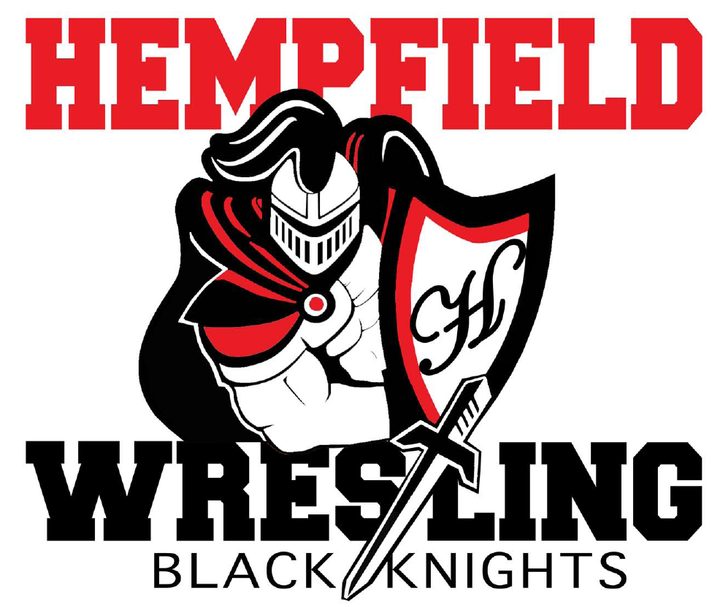
BOARD MEETING
Minutes

February 8, 2023

- I. Welcome - approval of minutes from January 9, 2023
Members Present: Jim Schopf (President), Ed Pfursich (Vice President), Josh Parmer (Secretary), Dr. Edwards, Bob Biddle, Al Houck, Chris Williams, Jim Lefever, Josh Mussman, Paul Karpathios, Lawrence Beckman
-The meeting was called to order by President Jim Schopf at 8:02 PM.
-A motion to approve the minutes from 1.9.23 was made by Bob Biddle and seconded by Dana Edwards. The minutes were then approved as read/distributed.
-The meeting proceeded according to the agenda set by the President.

II. Coach & Liaison Reports
- Girls – Houck get with Amy Edwards regarding her questions. Coach Houck reported on competitions in Gettysburg and Penn Manor. Coach Houck gave remarks on numbers of participants coming and going from the program and reported the team will begin training for freestyle competition.
- Youth – Feb 28 Rollerskating. Coach Biddle reported the Rolling Skating Party is set. He further reported for the program, remarking that many of the youth rooms are wrapping up for the regular season this week and next with some going longer due to regional/state competition. Coach Biddle gave remarks on numbers of participants during the year saying he maintain 60-70 participants through the season in his respective rooms. Presently Coach Biddle reports the youth wrestlers are competing in different tournaments this weekend including CPWA finals and the Manheim Township tournament. Lastly Coach Biddle reports that there is high interest in spring and summer training.
- Junior High – Northern Tourney 7th place, E-Town Tourney 3rd place. It was reported that some great wrestling accomplishments have been achieved this season, the team is working well together, and more wrestling opportunities are being pursued for the JV team in the following seasons. Joey Gallo was an E-Town Champ at 94 lbs.
- Senior High – Section 1 Champs, LL League Champs, District Team Qualifier, Sectionals and JV Tournaments upcoming. Wrestling accomplishments were highlighted as listed by Coach Schopf. Overall it was a successful season. Sectionals will occur next weekend. The Banquet is scheduled for May 10th, so the BKWC meeting then is rescheduled for May 3rd.

III. Treasurer’s Report
- Account Balance - See Treasurer’s report
- Outstanding Debits - See Treasurer’s report
- Outstanding Credits – See Treasurer’s report
- Other Info – See Treasurer’s report

IV. High School Banquet
- Need planning committee and date. Discussed as stated during Sr High comments. Matt York from Twisted Spoon will be catering.

V. Junior High School Banquet – Feb 19th
- Need planning committee. Will be held at Hempfield Brethren Church. A donation will be given. Coach Cote is working on that.

VI. Youth Banquet
- Need planning committee and date. Dates discussed were April 1st or April 2nd. Coach Beckman requested the April 2 date. Leftover programs should be given out.

VII. Sectionals Discussion – Feb 18, 2023 at Hempfield

A. Bracket Sponsor Fundraiser – sold 13 - $250 bracket sponsorships, one $250
donation, and one $500 podium backdrop sponsorship. Cost of 13 brackets is $730. Discussed as listed and the club projects a $3500.00 profit. Coach Schopf is working on a photographer for the awards.

B. Coaches Room – Amy Edwards, Jackie Pfursich, and Amber Biddle. Sign Up Genius has been sent out. Varsity Club gets ice, paper supplies, and water. There is still a need for help on this. Please sign up and encourage others to do so.

C.Awards Podium Backdrop – ordered, need frame built. Cost is $1,000.

D. JB Photographer set up? Again, Coach Schopf has been handling this.

E. Feb 17 – Mat and Table set-up in evening. All set and taken care of by the JH Team.

F. Other Topics. – Sell Beanies at matches

VIII. FUNDRAISING

A. CURRENT

- Raffle Tickets
  - High School has been given 1,421 tickets out with 1,096 confirmed sales and 325 more potentially. Goal was 525 tickets sold.
  - JH has been given 1,200 tickets. Goal was 1,250 tickets sold. Not sure about confirmed sales.
  - Youth has been given 2,725 tickets. Goal was 3,125 tickets sold. Not sure about confirmed sales. $9,000 has been confirmed on Team Snap.
  - There are 654 tickets still in stock to be sold.
  - Drawing is LIVE next meeting. All discussed as set in the agenda. Coach Schopf believes 5000 tickets will get sold, this would bring a profit of $13,000.00.

B. ONGOING – no real discussion needed

- Squadlocker Spiritwear – items are updated and on our website.

- Park City Diner Fundraiser Reminder

C. FUTURE – no real discussion needed.

- Restaurant partnerships (Hot Z, Trios, Caruso’s, MOD Pizza, Friendly’s, Fuddruckers, Isaac’s, Mission BBQ, Blue Collar, Chipotle, others?)

- Pancake Breakfast

- Chicken BBQ in Spring – Sunday May 21, 2023 – 1,000 tickets – sound good? Discussed whether to have it or not based on the Raffle happening so close. We will decide on whether to do it at the next meeting in March.

- Beckman Idea – kids ask 10 people to donate – POTENTIAL FUNDRAISER FOR NEXT SEASON.

IX. UPCOMING ITEMS
A. Open for discussion

X. NEW/UNFINISHED BUSINESS
- Thank you to Jim LeFevre for Sectional brackets, program, graphic work, etc.
- Thank you to Andrea Schopf for Sectional banner work.
- Thank you to Chris and Jamie Williams for Senior Night.
- Thank you to Amy Edwards for organizing program and National Anthem singers.
-All individuals mentioned were thanked and the club greatly appreciates their contributions to our success.
-President asked if there was anything else for the good of the order. Hearing none. Chris Williams made a motion to adjourn, it was seconded by Coach Houck and the motion was unanimously carried. The meeting closed at 9:02 pm.

Next Meeting Date Wednesday, March 8, 2023, at 7:00pm at The Barn

All meeting dates at hempfieldwrestling.com – Apr 12, May 3

